**BITWISE OPERATERS**

**Q1. WAP to read a 8 bit unsigned integer, interchange the adjacent bits i.e D0 with D1, D2 with D3….. D6 with D7. Display the final number.**

**Input: 0xAA**

**Output: 0x55**

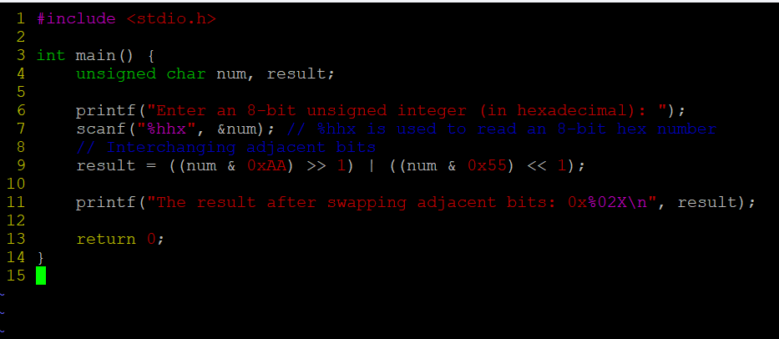

**OUTPUT:**



**Q2. WAP to count the number of 1’s in a given byte and display**

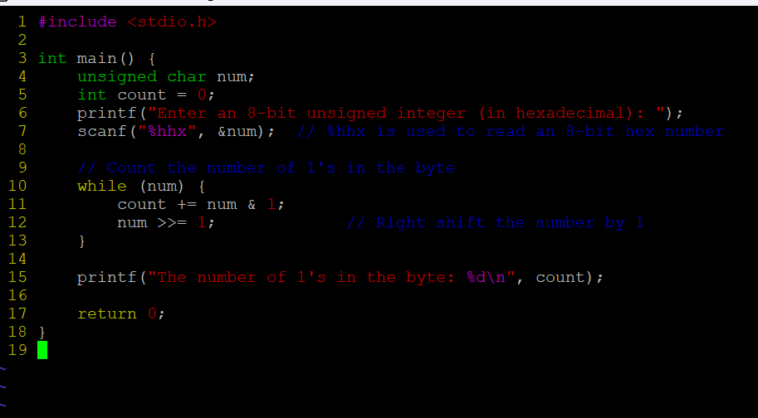

**OUTPUT:**

**Q3. Generate odd and even parity bits for a given number. (consider a 32 bit number)**

**[Hint: You may reuse the solution created in Q2 and extend it further]**

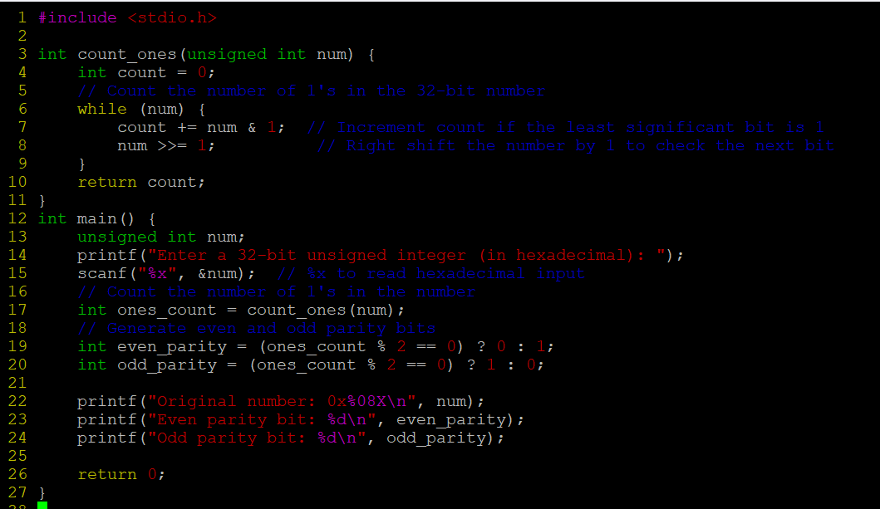

**OUTPUT:**

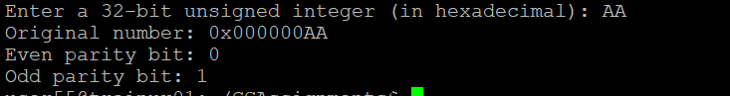

**Q4. WAP to reverse the bytes in a 32 but unsigned integer using shift operator.**

**Input: 0x12345678**

**Output: 0x78563412**

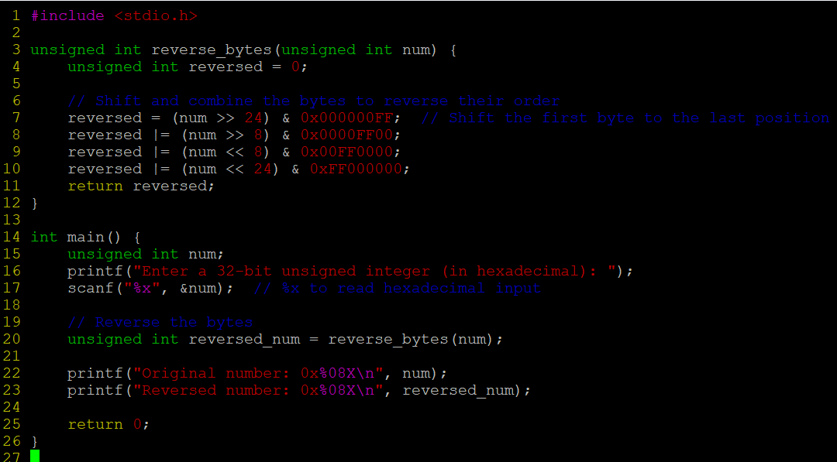

**OUTPUT:**

